

|  |
| --- |
| Photo displaying partial image of two pie charts on a canvas-textured page |
| Project Report  **LECTURER’S NAME: DR. ZAHEERA BINTI ZAINAL ABIDIN** |
| |  |  |  | | --- | --- | --- | | Group Name:KeepAlive | 1/6/22 | BITS 3363 Network Security Project Management | |

FACULTY OF INFORMATION AND COMMUNICATION TECHNOLOGY

SEMESTER 1-2021-2022

**PREPARED BY: KeepAlive**

**1. Muhammad Izham Bin Norhamadi (B032020039)**

**2. Ahmad Sha Herizam Bin Tahir (B032020009)**

**3. Muhammad Firdaus Hafizi Bin Sabri (B032020037)**

**4. Muhammad Rifqi Bin Ramlan (B032020028)**

**5. Affendy Elyas bin Azhari Sharidan (B032020024)**

**6. Muhammad Imran Bin Rosli (B032020043)**

**TABLE OF CONTENT**

|  |  |  |
| --- | --- | --- |
| **CONTENT** | | **PAGE NO** |
| 1.0. | COMPANY PROFILE | 2 |
| 2.0. | SCOPE | 8 |
|  | Project Charter | 8 |
|  | Scope Planning - Statement Plan Details and Scope Management Plan | 10 |
|  | Scope Definition – Work Breakdown Structure | 12 |
| 3.0. | TIME – Activity Definition, Sequence, Duration, Development  Gantt Chart, Milestone, PERT | 16 |
| 4.0. | COST – Resource Planning and Cost estimating | 18 |
| 5.0. | QUALITY – Quality Cost Planning, Operational Budget | 21 |
| 6.0 | NETWORK SECURITY AUDIT AND RISK ASSESSMENT | 22 |
|  | Identification – Asset, Threat and Vulnerability | 22 |
|  | Risk Mitigation Planning - for each identification | 22 |
| 7.0 | PROPOSED SOLUTION | 23 |
|  | Planning and designing the proposed solution | 23 |
|  | Lesson Learned | 26 |

1. **COMPANY PROFILE**

Background and culture/nature of the business

Advanced Cybersecurity and Programming (ACaP) Solution Sdn. Bhd. is a company specializing in providing advance security to an organization network environment and developing reliable systems. Our CEO, Tan Sri Affendy Imran Rifqi bin Datuk Wira Izham Ahmad Firdaus is very committed in ensuring every organization has a good security measures to protect their data properly. We are non governmental organizations and currently receiving funds from third party companies such as Proton, Intel and Konica Minolta. We specialize in developing secure network infrastructure and provide advance security in protecting data from both outside and inside attack. Our mission is to deliver top security management to our clients. We aim to keep our clients worry free about the safety of their company data.

We are now working on installing a new email server for Proton Holdings Berhad. As new cyber security threats always surface around email phishing, we have to provide better security to protect the employees of the company from this attack. Therefore, we are developing secure network environment for this purposes.

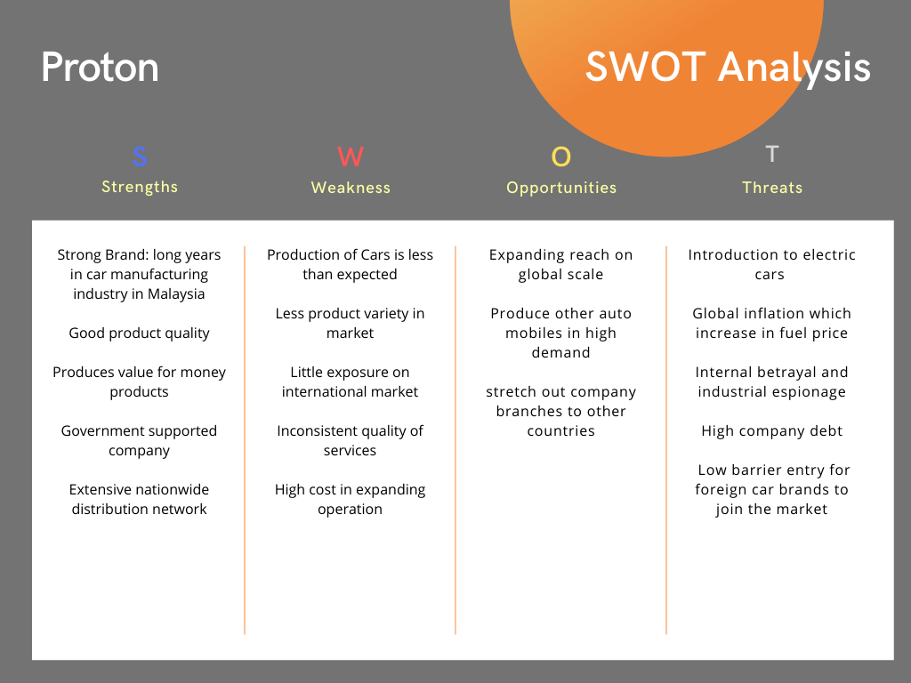

Figure 1.1 Proton SWOT Analysis

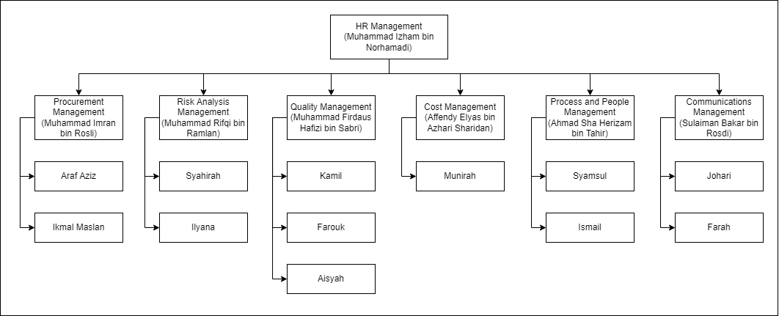

Figure 1.2 Organizational Chart for Network Attack and Penetration Project

The upper management of the company requested a secured email system to coordinate with employees within, as the company continues to expand its operations. This means more confidential data may be required to be transported using a secure channel to prevent data leaks that may compromise operations.

**Meeting 1– written progress report**

**Date: 6/11/2021**

The project revolves around setting up the E-mail server as well as the appropriate services to go along with it. This project purpose is to provide secured way of exchanging email whether from inside or outside the network of our client company. The time allocated for the completion of this project is estimated around 95 of working days. There are around 19 employees varies from different specialty from our company has been appointed to complete this project. The estimated cost to finish this project is around RM43,000 funded by our company.

Our project also setup a SpamTitan as security services with the various features in SpamTitan for the client company. SpamTitan is for email protection by blocking spam, viruses, malware, ransomware, and links to malicious websites from your emails. The time allocated to install this service only take approximately one hour. The cost of this service is RM 4 per user for each month.

|  |  |  |
| --- | --- | --- |
| Action Item | Assigned To | Due Date |
| Work Breakdown Structure | HR and Scope Management | 6/11/2021 |
| Organizational Chart | HR and Scope Management | 7/11/2021 |
| Gantt Chart | Project, Process and People Management | 7/11/2021 |
| Risk Analysis Layout | Risk Analysis Management | 8/11/2021 |
| Defining stakeholders | Project, People and Process Management | 13/11/2021 |
| Commence quality planning, assurance and control | Quality Management | 17/11/2021 |
| Budget Estimation | Cost and Time Management | 20/11/2021 |
| Provide Make-or-Buy Analysis and Appropriate Sellers | Procurement Management | 22/11/2021 |
| Provide training and bonding with other organizations. | Communication Management | 27/11/2021 |

Date and time of next meeting: 16/12/2021

**Roles and Responsibilities**

|  |  |  |  |
| --- | --- | --- | --- |
| **Role** | **Name** | **Organization/**  **Position** | **Contact Information** |
| HR Manager | Muhammad Izham Bin Norhamadi | HR Leader | Izham@gmail.com |
| Procurement Manager | Muhammad Imran Bin Rosli | Procurement Leader | Imran@gmail.com |
| Quality Manager | Muhammad Firdaus Hafizi Bin Sabri | Quality Leader | Aus@gmail.com |
| Risk Analysis Manager | Muhammad Rifqi Bin Ramlan | Risk Analysis Leader | Rifqi@gmail.com |
| Cost Manager | Affendy Elyas bin Azhari Sharidan | Cost Leader | affendy0212@gmail.com |
| Process and People Manager | Ahmad Sha Herizam Bin Tahir | Process and People Leader | Ahmad@gmail.com |
| Communications Manager | Sulaiman Bakar Bin Rosdi | Communication Leader | Imran@gmail.com |

**Sign-off:** (Signatures of all above stakeholders. Can sign by their names in table above.)

**Comments:** (Handwritten or typed comments from above stakeholders, if applicable)

**Team Contract**

**Project Team Members Names and Sign-off:**

|  |  |
| --- | --- |
| **Name** | **Sign-off on Team Contract** |
| Muhammad Imran Bin Rosli | *Imran* |
| Muhammad Izham Bin Norhamadi | Izham |
| Ahmad Sha Herizam Bin Tahir | Ahmad |
| Affendy Elyas bin Azhari Sharidan | *Affendy* |
| Muhammad Rifqi Bin Ramlan | *Rifqi* |
| Muhammad Firdaus Hafizi Bin Sabri | Firdaus |

**Code of Conduct: As** one of the project members, I will:

* Work as a team and finish up the project until the end of the project.
* Research and help each other in developing this project.
* Commit to our work and abide by all the rules being set by this organization.

**Participation:**

* Give full effort and energy so that the project runs smoothly.
* Ask for help if does not know how to complete a task.
* Report any circumstances to the leader.

**Communication:**

* Communicate effectively with each other to meet the project’s needs.
* Brainstorm and set up meetings to update each work that has been done.
* Meet up not only at workplace but also during free time.

**Problem Solving:**

* Analyze and provide a solution if necessary.
* Link and bonding with other organizations to tackle problems.

**2.0 SCOPE**

Project Charter

Date: 12/1/2021

|  |  |  |  |
| --- | --- | --- | --- |
| **Project Title**: Setting up Email Server for Proton Holdings Berhad | | | |
| **Project Start Date:** 11/1/2021  **Projected Finish Date:** 3/11/2022 | | | |
| **Budget Information:** RM49,500.00 | | | |
| **Project Manager:** Muhammad Izham Bin Norhamadi | | | |
| **Project Objectives:**  Our project objective is to set up an email server that is secured from cyber threat. This is to provide Proton Holdings Berhad employees with a secure way to exchange email inside or outside of Proton’s network. This way, the email will only be sent to the desired recipient and reduces risk of email phishing, spamming and man in the middle attack and some others famous cyber-attack known nowadays. | | | |
| **Success Criteria:**  -Project completed on time with all known errors has already been fixed.  - Project completed around the margin of the allocated budget.  - Project provides efficiency and boosts productivity also increases the company general income.  - Project objectives such as a secure way for employees to exchange email inside and outside of proton network are achieved completely. | | | |
| **Approach:**   * Hired specialized employees regarding networks such as network administrator, cyber security engineer and network engineer. * Assign each employee to the appropriate group based on their specialty. * Consult with project manager and project leaders in order to understand the details and requirements of the project. * Brainstorm with every group member to further analyze project requirements. * Developed the project based on the project guidelines. * Meeting and brainstorming with stakeholders, project leader and manager, also group members if necessary. * Keep the client up to date with the project progress in order to ensure the project is developed based on the client requirements. | | | |
| **Roles and Responsibilities** | | | |
| ***Name and Signature*** | ***Role*** | ***Position*** | ***Contact Information*** |
| Muhammad Imran Bin Rosli *Imran* | HR Manager | HR Leader | Imran@gmail.com |
| Muhammad Izham Bin Norhamadi Izham | Procurement Manager | Procurement Leader | Izham@gmail.com |
| Muhammad Firdaus Hafizi Bin Sabri Firdaus | Quality Manager | Quality Leader | Aus@gmail.com |
|  | | | |
| **Comments:** (Handwritten or typed comments from above stakeholders, if applicable) | | | |

**Scope Planning**

Scope Statement

|  |
| --- |
| **Project Title:** Setting up Email Server for Proton Holdings Berhad  **Date:** 11/1/2021 **Prepared by:** Muhammad Izham Bin Norhamadi |
| **Project Justification:**  Email server is essential for a business company or any organization as it is one of the formal and crucial platforms for exchanging information. Nowadays, there are various type of cyber-attacks known targeting the email, such as man in the middle attack, email spamming and phishing. Thus, it is crucial to have a secure email server for the employees to exchange email with each other or with any outside users. This is to ensure that business can run as usual and reduce the risk of threat that can halt the business flow. |
| **Product Characteristics and Requirements:**   * The services provided must protect the email that is exchanged inside or outside Proton’s network. * The email services must be up to date and meet today's standard. * Reduce administrative costs, overheads, and human error. * The product must meet all stakeholders' interests and requirements. * The email server configuration is based on network administrator guidelines. |
| **Product User Acceptance Criteria:**   * Reduces risk of man in the middle attacks. * It has an anti-spam feature to eliminate email spamming. * The email server performance is not bottleneck by any network configurations. * The email services must have automatic update features.   **Summary of Project Deliverables**  The email server has an email services and other security services such as IDS in order to safeguard the confidentiality and integrity of the email. This includes reducing cyber-attack targeting email such as man in the middle attack, eliminate email spamming and filter suspicious email to reduces risk of email phishing. It can ensure the email that is being exchanged inside or outside of Proton’s network is safe.  **Project management-related deliverables:**   * The actual cost of the project after it is finished. * Document of each process involved in completing the project. * Project objectives that have been successfully achieved. * The requirements of the stakeholders that have been successfully satisfied.   **Product-related deliverables:**   * The email server. * The email services as well as other services that provide security for email and the network in general. * Updated and free of known misconfiguration of email services. * The product is functioning properly as intended. |

**Scope Definition**

Proton Holdings Berhad known as Proton is a car manufacturer which was established in 1983, where former prime minister of Malaysia, Tun Dr. Mahathir Mohamad conceived a vision to produce a national car.

Proton in its early existence was a joint venture company where they used to manufacture rebadged versions of Mitsubishi Motors (MMS) products in the 1980s and 1990s. In the year 2000, Proton managed to produce its first non-badge engineered car although still using Mitsubishi-engined. The first national car ever produced by Proton is Proton Saga.

Proton was owned in majority by HICOM with minority stakes is hold by Mitsubishi Group. In 2012, Proton was fully acquired by DRB-HICOM after Mitsubishi divested their stake to Khazanah Nasional in 2005. Proton has expanded their businesses to over 70 countries to date. The latest car manufactured by Proton is Proton X70, Proton X50 and the new model of Proton Persona.

**Choose your clients from various domains:**

* Domain: **Car Manufacturer** – Client: **Proton Holdings Berhad**

**Weighted Scoring Method**

Projects are listed based on the requirements and weighted for decision making. The criteria of the product or services that will be implemented is listed in Table 1.

|  |  |  |  |  |  |  |
| --- | --- | --- | --- | --- | --- | --- |
|  |  | Requirement Score | | | | |
| Criteria | Weight | A | B | C | D | E |
| Value | 15% | 75 | 50 | 30 | 20 | 40 |
| Risk | 20% | 50 | 60 | 40 | 15 | 70 |
| Difficulty | 10% | 50 | 65 | 55 | 10 | 30 |
| Success | 15% | 35 | 50 | 45 | 70 | 35 |
| Compliance | 10% | 30 | 60 | 55 | 40 | 45 |
| Relationship | 5% | 60 | 45 | 45 | 75 | 70 |
| Stakeholder | 20% | 30 | 40 | 50 | 50 | 60 |
| Urgency | 5% | 55 | 50 | 50 | 60 | 75 |
| Weighted Scores | 100% | 46.25 | 52.25 | 45.00 | 38.25 | 77.00 |

**Weighted Scoring Method (WBS)**

**STAKEHOLDER ANALYSIS**

* **Stakeholder Analysis for Network Security Infrastructure**
* **Prepared by:** Muhammad Firdaus Hafizi bin Sabri **Date:** 11/1/2021

|  |  |  |  |  |  |  |
| --- | --- | --- | --- | --- | --- | --- |
| **Name** | **Organization** | **Role on project** | **Unique facts about stakeholder** | **Level of interest** | **Level of influence** | **Suggestions on managing relationships** |
| Raziman Abd Rahman | Proton Holdings Bhd. | Client | Generous | High | High | Always present ideas confidently to convince the project sponsor from supporting the project. |
| Amirah Farhana | Konica Minolta, Inc. | Project Sponsor | Generous | High | High | Report the status of progress project on time to project sponsor and conduct small meeting when necessary. |
| Aznil  Karen Ng | Seiko Epson Corporation | Project Sponsor | Resourceful  Kind | High | High | Always help each other in the process of completing the project. |
| Syakirin | ANTIQ Solution | Software resource | Patience | High | High | Explain the project nicely and clear customers’ doubts with clear explanation. |

**3.0 TIME**

The initiation phase takes only 10 days because the phase consists of general task like choosing server and routers, making network design and choosing which OS need to be installed in the server. The process includes developing IP addressing table, creating suitable VLAN for the new server and analyzing the old network topology to look for improvement. In the planning phase, it takes 7 days to perform where it consists of the task of electing database administrator and going to the project site where the new server is going to be placed to determine where the server is going to be placed.

The execution phase takes the longest time to complete which is 56 days, and the 2 task that hogging the time taken is installing hardware and improve site performance that taking a total of 42 days. During this process, the new server is going to be placed into the site. The server will be configured by the installation team. This includes the work of constructing the server rack and other cabling work. After that, the server will be configured by the configuration team. When the server has been fired up, the control team will take the responsibilities to keep the server in good condition and secured by applying thorough security measures.

Control phases consist of many maintenance tasks such as monthly maintenance, check server integrity and security check up that need 15 days to complete. During this phase, the control team needs to do make sure the server is always working and in good condition. The last phase is closing that only take 9 days to complete. During this phase, the report is being documented for presentation.

**4.0 COST**

The plan for spending on resources, as stated in the Workbench, is around RM15,000.00, which includes the cost of server, server rack, and email protocols to safeguard the network. Tangible costs include resources and hardware such as computers, but intangible costs include money spent on software such as management software, the price of which may change. Direct labor or employee pay rates, as well as direct materials for the project, are examples of materials for direct cost. Indirect costs, on the other hand, are used to pay for things like office rent, utilities, and ordinary office expenditures like power, paper, Wi-Fi, and printer inks.

**4.1 Resources**

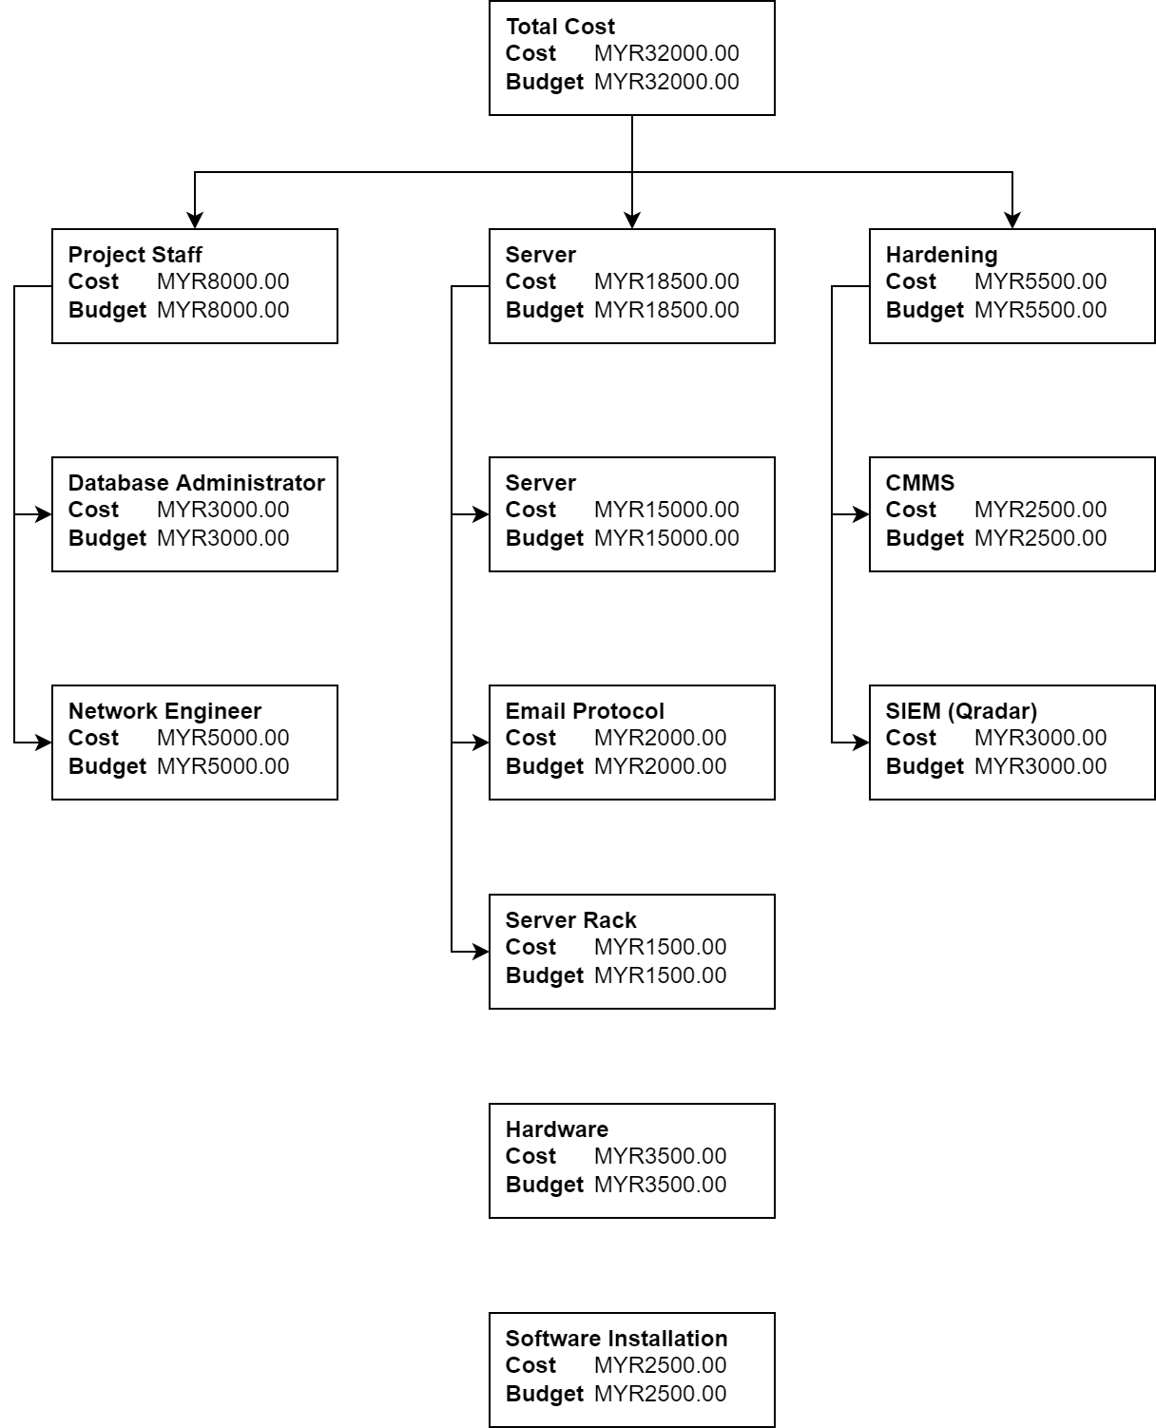

**4.2 RBS Figure**

**5.0 QUALITY**

Improving quality of service is most important in an organization to attract and gain the trust of client and user. Because there are fewer defects and greater accuracy throughout the implementation phase, improving the Quality of Service will immediately affect the project's development to become faster and more accurate. The fishbone figure below depicts the disadvantages that may arise during the project's implementation.

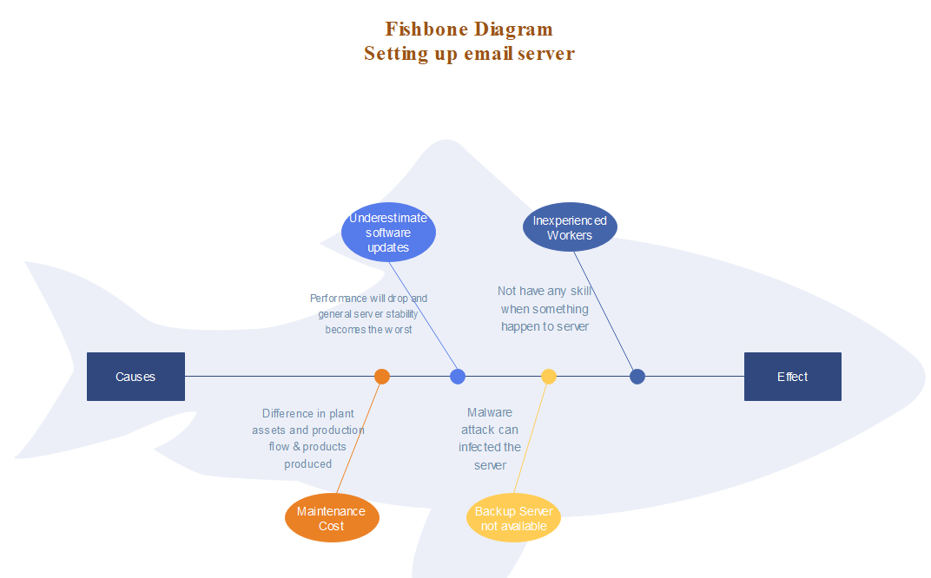

We also use ISO/IEC 27001:2013 to standardize our operation as it helps us in email policies: -

1. Proton employees are eligible to apply for the Proton official account for official purposes only.

2. The documentation shall consist of guidelines, and policies & procedures for acceptable use of each service

3. The policy document shall be considered as “confidential” and shall be made available to the concerned persons with proper access control. Subsequent changes and versions of this document shall be controlled

Flowchart on testing email server is shown below.

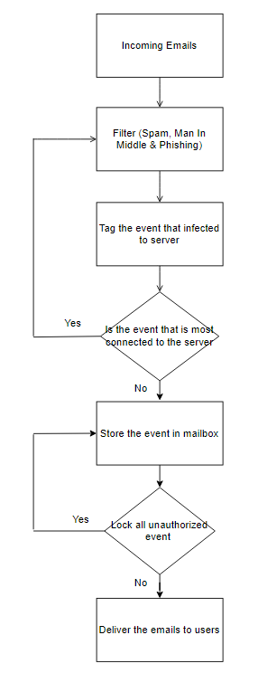

**6.0 NETWORK SECURITY AUDIT AND ASSESSMENT**

|  |  |  |  |  |  |  |
| --- | --- | --- | --- | --- | --- | --- |
| 3 pillars of cyber security | Assets | Assets  Description | Vulnerability | Threats | Risks | Risk Mitigation |
| People | * Talent * Strength * Discipline * Loyalty * Smart | * Employee | * Inconsistent * Learning curve * Health condition * Family status | * Careless * Irresponsible * Corruption | * Low in productivity * Low in work quality | * Job posting * Training |
| Process | * Policy * Rules and regulations * Term and conditions | * Car manufacturing process * Quality control * Account authentication | * RFID skimming * Piggybacking * Tailgating | * Confusion of process * Forgetful * Ignorance * ill intent | * Bottleneck production * Dictionary attack * Brute force * Phishing * Social engineering | * Fully train employee * Awareness campaign |
| Technology | * Hardware | * Car Manufacturing Machine * Router * Computer * Switch * Server | * Faulty machine * Software patches * Backdoor * Bug | * Failure in car manufacturing machine * Mishandling machine * No electricity * Natural disaster | * Loss of assets * Re-direction of path | * Machine Maintenance * Hardware redundance * Firewall |
| * Software | * Proton manufacture management system | * Data reliability | * Data breach * Malware attack | * Leak of confidential data | * Proxy * Backup and recovery * Antivirus |

**Table 1**: Identification (Assets, Threats, Risks and Mitigation Planning)

**Client: Proton Holdings Berhad**

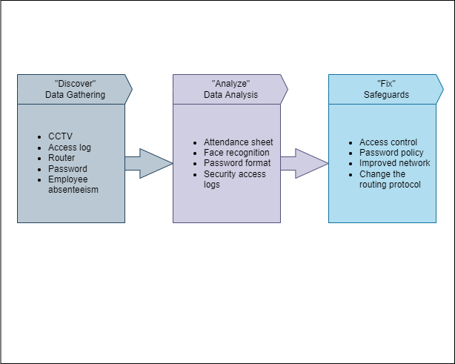

Figure 1: Iterative Assessment Map – Proton Holdings Berhad as a Client

# **7.0 PROPOSED SOLUTION**

**Planning and Designing Logical and Physical Topologies**

In the planning and designing process, the project team produces the logical topology and physical topology of the network security architecture. The project manager needs to manage the server and avoid what any can infected in server as shown in Figure 7.1 & 7.2, design the security services and security in servers. Figure 7.3 shows example of logical and physical topology or also called as network architecture.

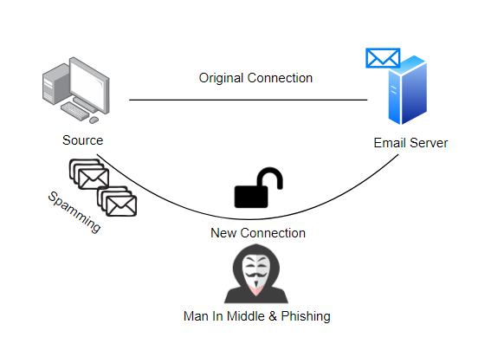

Figure 7.1: Before email server is established

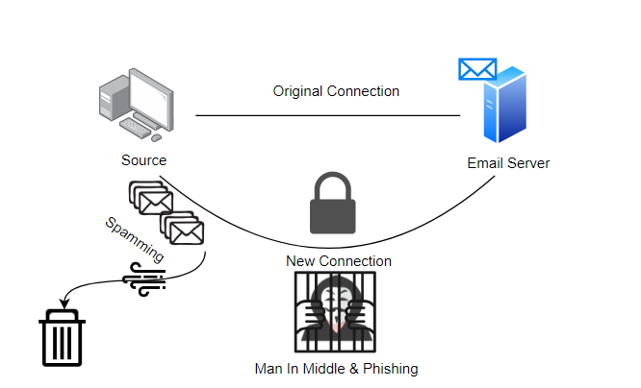

Figure 7.2: After email server is established

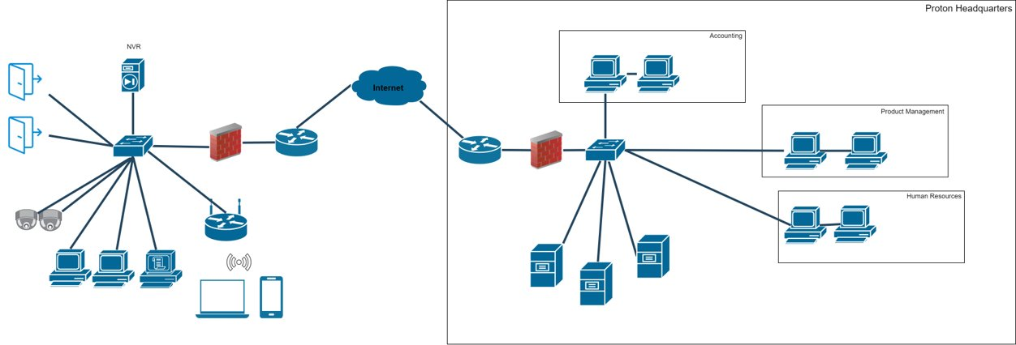

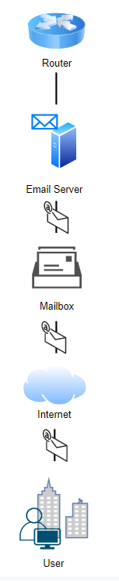

Figure 7.3: Network Architecture

**Lessons Learned Report**

|  |
| --- |
| **Prepared by:** HR Management **Date:** 4/11/2022  **Project Name:** Setting up Email Server for Proton Holdings Berhad  **Project Sponsor:** Proton Holdings Berhad  **Project Manager:** Muhammad Izham Bin Norhamadi  **Project Dates:** 11/1/2021 – 3/11/2022  **Final Budget:**  RM49,500.00 |
| 1. Did the project meet scope, time, and cost goals?  * Yes, the project meets the scope, time and cost goals.  1. What was the success criteria listed in the project scope statement?  * Project finished on time or quicker. * Project came in the range of budget * Project created financial benefit for your organization. * Project will make protection of the client organization better  1. Reflect on whether or not you met the project success criteria.  * Our project met the success criteria that is needed in the project requirement.  1. In terms of managing the project, what were the main lessons your team learned?  * Our team learns how to handle a network security project and create an proper document.   5. Describe one example of what went right on this project.  The email services function properly as intended according to the stakeholder's requirements.  6. Describe one example of what went wrong on this project.  Automatic update of email services encounters some errors.  7. What will you do differently on the next project based on your experience  working on this project?   * Increase the meeting count with stakeholders, project leader and other group members to increase their productivity. |